Compound velocity formula in special relativity
by Phillips V. Bradford, Sc.D.
A simple algebraic method of determining the compound velocity formula in special relativity. In The Principle of Relativity - a collection of original memoirs on the special and general theory of relativity, by H.A. Lorentz, A. Einstein, H. Minkowski, and H. Weyl; Dover Publications, 1952, page 51, Einstein states in regard to the composition of velocities: "We might also have obtained the formula for V [the composition of two velocities], for the case when v and w [the two velocities in his treatment] have the same direction, by compounding the two transformations in accordance with paragraph 3 [the paragraph in which he shows the Lorentz transformation].
Using this hint, the following simple algebraic treatment is offered
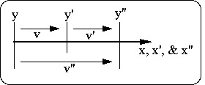

Consider an inertial reference frame at rest (the "unprimed" frame) recording an event at a distance, x, and a time, t. Then consider another inertial reference frame (the "primed" frame) in uniform motion at velocity, v, in the x-direction. An observer in the primed frame measures the same event at x’ and t’.
According to the special theory of relativity, measurements observed in the primed frame are related to those in the rest frame by the Lorentz transformation, shown in equations (1) below.
Now further consider yet another frame of referance (the "double-primed" frame) in uniform motion at velocity, v’, with respect to the primed frame, in the x-direction. The Lorentz transformation between the doubled-primed and the primed frames are shown in equations (2). Note, that equations (2) are identical to equations (1) with every term given an additional prime, except the speed of light, c, which stays the same in all three frames.
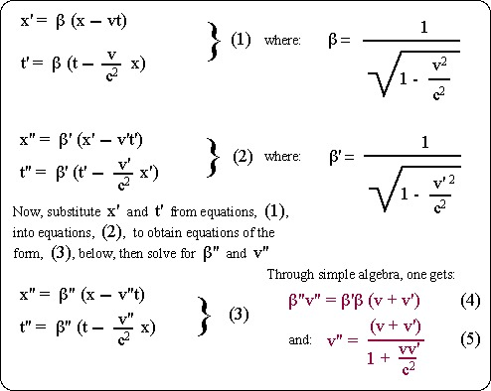

Equation (5) is the well-recognized formula for the compounding of two velocities in special relativity. It is sometimes referred to as the "velocity addition formula", but should be understood as the "velocity compounding formula". Equation (4) is algebraically equivalent to equation (5), in that each can be derived from the other. Heuristically, equation (4) is attractive; the compound beta-velocity product for two velocities is simply the product of the betas times the sum of the velocities!

